**Desert Southwest CFC**

**Materials Order Form**

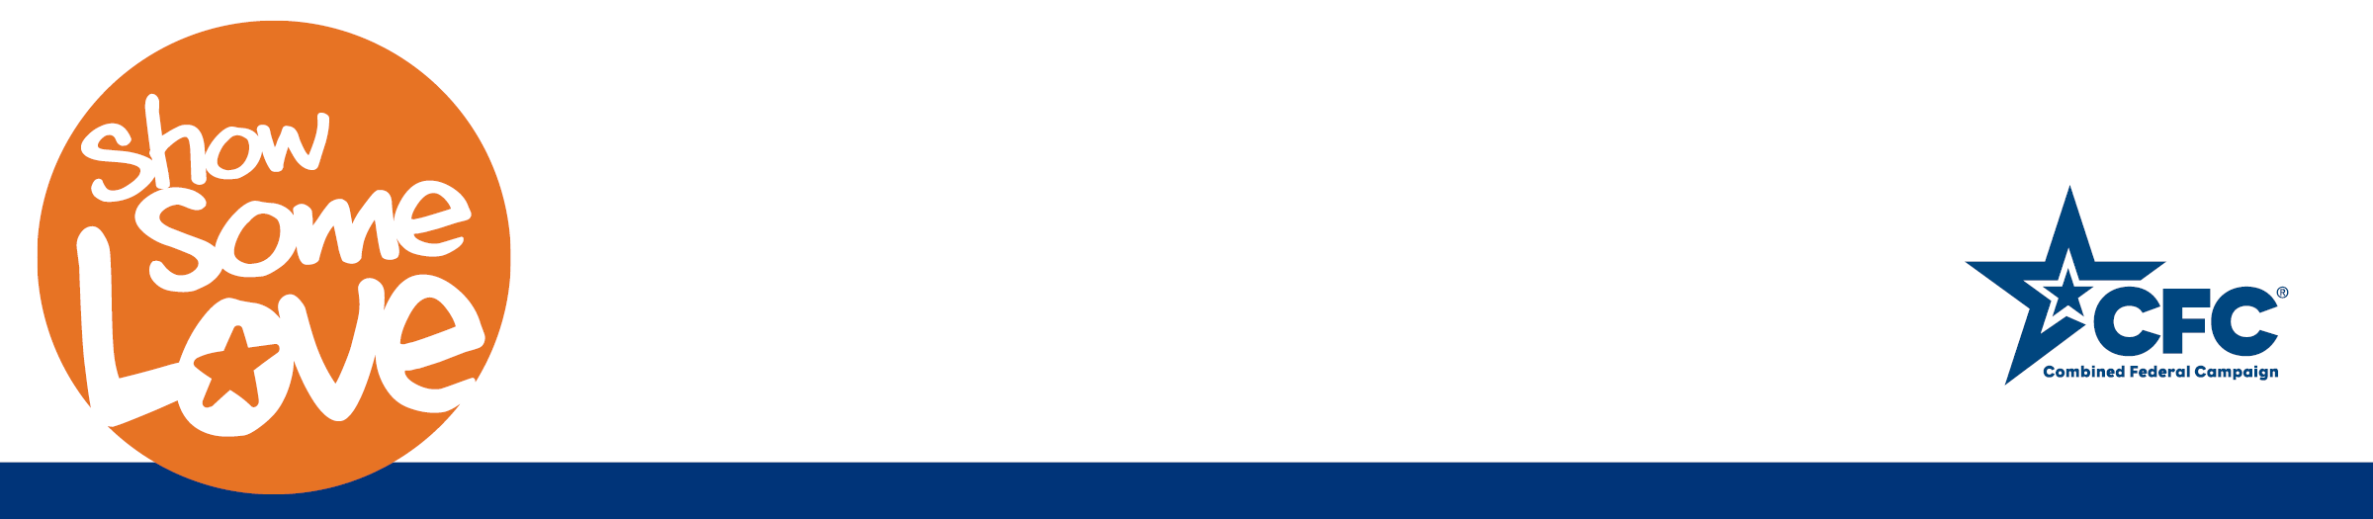

Desert Southwest CFC reserves the option to adjust the quantity of materials requested at its discretion based on available supply. Additional downloadable materials including Campaign Management Guides, posters, pledge forms, donor cards and CFC Event Guides can be found at: Northern CaliforniaCFC.GiveCFC.org.

Please send this completed form to Cyndi ([cankiewicz@kaptivategroup.com](mailto:cankiewicz@kaptivategroup.com)). Thank you!

Event Coordinator First/Last Name:

Email: Phone:

Department/Agency/Office or Unit: (example: Dept of Energy, NNSA, City)

Physical Shipping Address (No PO Boxes):

Address:

City: State: Zip:

Special Shipping Instructions (if any)

Number of Employees NOT Working Remotely:

Indicate the quantities of the following items you would like, based on the people working in the field (*note: people working remotely do not need CFC materials mailed as all materials are available electronically)*

Charity Listing Catalogs:

Pledge Forms:

Posters:

Donor Cards:

